**2. ReactJS – HOL**

**1. Explain React Components**

* React component is a **reusable block of UI**.
* It defines **how a part of the interface should look and behave**.
* Components return **HTML using JSX**.
* They help build **modular, maintainable** code.
* Two main types: **Class components** and **Function components**.

**2. Identify the Differences Between Components and JavaScript Functions**

|  |  |  |
| --- | --- | --- |
| **Feature** | **React Components** | **JavaScript Functions** |
| Purpose | Build UI elements | Perform calculations or tasks |
| Return Type | Returns JSX (HTML-like code) | Returns data or values |
| React-specific Features | Can use state, props, lifecycle | Cannot use React features directly |
| Usage | Used inside React app | Used anywhere in JS |
| Type | Component Function or Class | Simple function |

**3. Identify the Types of Components**

There are **two main types** of components in React:

1. **Class Component**
2. **Function Component**

Bonus:

* **Pure Component** (for optimization)
* **Higher-Order Component** (advanced reuse pattern)

**4. Explain Class Component**

* Uses **ES6 class** syntax.
* Must extend React.Component.
* Has access to **state** and **lifecycle methods** like componentDidMount().
* Needs a **render()** method to return JSX.

**Example:**

class MyComponent extends React.Component {

render() {

return <h1>Hello from Class Component</h1>;

}

}

**5. Explain Function Component**

* A **simple JavaScript function** that returns JSX.
* In modern React, it can use **hooks** (like useState, useEffect) to handle state and lifecycle.
* Easier and more lightweight than class components.

**Example:**

function MyComponent() {

return <h1>Hello from Function Component</h1>;

}

**6. Define Component Constructor**

* Used **only in class components**.
* A special method to **initialize state** and **bind methods**.
* Called before the component is mounted.

**Syntax:**

constructor(props) {

super(props);

this.state = { name: "Priii" };

}

**7. Define render() Function**

* Used in **class components only**.
* It **returns the JSX** that defines what to display in the UI.
* React **calls this function automatically** when the component needs to update.

**Example:**

render() {

return <div>Welcome, Priii!</div>;

}

**React Application : StudentApp**

1. Create a React project named “StudentApp” type the following command in terminal of Visual studio:



1. Create a new folder under Src folder with the name “Components”. Add a new file named “Home.js”
2. Type the following code in Home.js

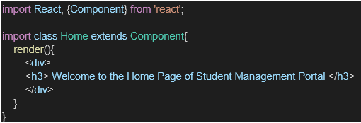

1. Under Src folder add another file named “About.js”
2. Repeat the same steps for Creating “About” and “Contact” component by adding a new file as ”About.js”, “Contact.js” under “Src” folder and edit the code as mentioned for “Home” Component.
3. Edit the App.js to invoke the Home, About and Contact component as follows:

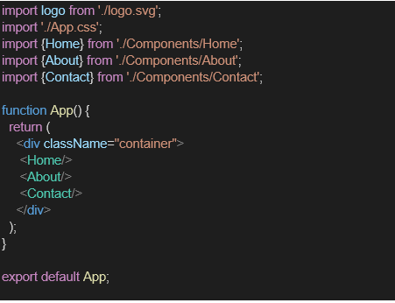

1. In command Prompt, navigate into StudentApp and execute the code by typing the following command:



1. Open browser and type “localhost:3000” in the address bar:

Final Output:

